

INSTITUTE FOR ADVANCED COMPUTING AND SOFTWARE DEVELOPMENT AKURDI, (IACSD) PUNE.

Documentation On

“**ZykaExpress**”

***PG-DAC March 2024.***

*Submitted By :*

**Group No: 23**

# Roll No. Name

**243108 Vaibhav Singh**

# 243042 Akash Kendre

# 243061 Bharat Phulzalke

**Mrs. Vaishnavi Ghodke Mr. Rohit Puranik Project Guide Course Coordinator**

# Table of Contents

1. Introduction 1

Problem Statement 1

Aim & Objectives 1

1. Overall Description 2

Proposed Methodology 2

Operating Environment 2

Design and Implementation Constraints 3

1. Requirements Specification 4

External Interface Requirements 4

1. System Diagram 5

Activity Diagram 5

Data Flow Diagram 8

Class Diagram 10

Use Case Diagram 11

ER Diagram 12

1. Table Structure 15

Customer 13

Delivery_person 13

Food_item 13

Food_type 14

Order_item 14

Orders_Payment 14

Restaurant 15

Restaurant_Manager 15

1. Conclusion 19

Future Scope 19

1. Appendix 20
2. References 20

**List of Figures**

Figure 1 Customer Activity Diagram 5

Figure 2 Restaurant Manager Activity Diagram 6

Figure 3 Delivery Person Activity Diagram 7

Figure 4 Level 0 Data Flow Diagram 8

Figure 5 Level 1 Data Flow Diagram 8

Figure 6 Level 2 Data Flow Diagram for Customer 9

Figure 7 Class Diagram 10

Figure 9 Use Case Diagram for Student 11

Use Case Diagram for Faculty 11

Use Case Diagram for Admin 11

Figure 10 ER Diagram 13

**Introduction:**

# INTRODUCTION.



This online food portal is the one stop web application which enables restaurants to showcase their cuisines online, customers to browse through the portal and order the food.Portal provide user with easy, personalized web-interface for facilitating access to restaurant information and food services that are of primary relevance and interests to the users. ZykaExpress food Portal is nothing but a portal which thinks customers as the main target users and provides so many useful services to customers at a single place. It helps to deliver various cuisine from various restaurant to customers with the help of delivery person.

## Problem Statement:

There are many problems found in the today’s food portal system. The problems created in the existing system enforced us to develop the new system which minimize the problem of the existing system. The problems are Low quality of food, Unhygienic kitchen and lack of inclusion of all type of food. Its application depends on location of the customer and location of restaurant.

## Aims and Objective:

The main purpose of this system, is to increase the awareness about various food items available in an area. To make cross cultural awareness among the people and to generate the feeling of oneness. Provide on time delivery of foods. In other words, our food portal has, following objectives:

Simple database is maintained.

Easy operations for the operator of the system.

User interfaces are user accommodating and attractive; it takes very less time for the to use the system.

*Easy operations for the operator of the system.

1

# OVERALL DESCRIPTION.

## Proposed Methodology:

This system provides an easy way for customers to view and order the various cuisines. Restaurant staff to manage their food orders and deliver the food with help of delivery persons. The online food portal enables restaurants (system user) to showcase their cuisines online, customers to browse through portal can buy the food. This product aims towards a person who don’t want to visit the restaurants but want to taste the food items in his home or office etc. She/he can use the web application for ease.

## Operating Environment:

Server Side:

**Processor:** Intel® Core i5 8th Gen **HDD:** Minimum 1TB Disk Space **RAM:** Minimum 8GB

**OS:** Windows 10, Linux 6

**Database:** MySQL

Client Side (minimum requirement):

**Processor:** Intel Dual Core

**HDD:** Minimum 500GB Disk Space

**RAM:** Minimum 4GB

**OS:** Windows 10, Linux

2

## Design and Implementation Constraints:

* The application will use ReactJs as frontend and Java spring Boot Api as a backend.
* The application will use JavaScript, JQuery and CSS as web technologies.
* HTTP and FTP protocols are used as communication protocols. FTP is used to upload the web application in live domain and the client can access it via HTTP protocol.
* SMTP protocol is used for Email communication.
* Several types of validations make this web application a secured one and SQL Injections can also be prevented.
* Since ZykaExpress Online Food Portal is a web-based application, internet connection must beestablished.
* The ZykaExpress Online Food Portal will be used on PCs and will function via internet or intranetin any web browser.

3

# .

* 1. **REQUIREMENTS SPECIFICATION**

## External Interface Requirements

User Interfaces:

* All the users will see the same page when they enter in this website. This page asks the users a username and a password.
* After being authenticated by correct username and password, user will be redirect totheir corresponding profile where they can do various activities.
* The user interface will be simple and consistence, using terminology commonly understood by intended users of the system. The system will have simple interface, consistence with standard interface, to eliminate need for user training of infrequent users.

Hardware Interfaces:

* No extra hardware interfaces are needed.
* The system will use the standard hardware and data communication resources.

This includes, but not limited to, general network connection at the server/hosting site, network server and network management tools.

Application Interfaces:

**Web Browser:**

The system is a web-based application; clients need a modern web browser such as Mozilla Firebox, Internet Explorer, Opera, and Chrome. The computer must have an Internet connection in order to be able to access the system.

Communications Interfaces:

* This system uses communication resources which includes but not limited to, HTTP protocol for communication with the web browser and web server and TCP/IP network protocol with HTTP protocol.
* This application will communicate with the database that holds all the Orders information. Users can contact with server side through HTTP protocol by means of a function that is called HTTP Service. This function allows the application to use thedata retrieved by server to fulfil the request fired by the customer.

4

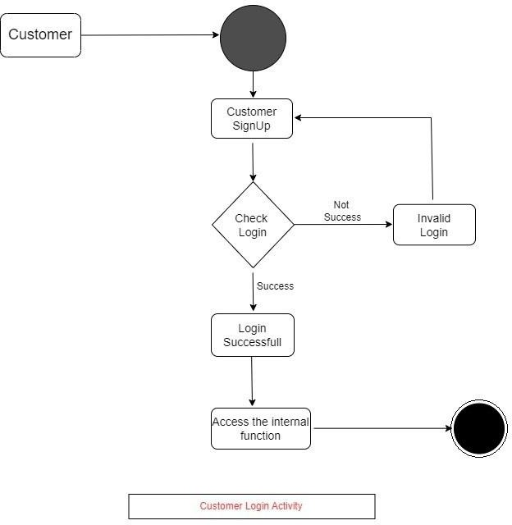

# SYSTEM DAIGRAMS.

## Activity Diagram:

*Customer Activity:



5

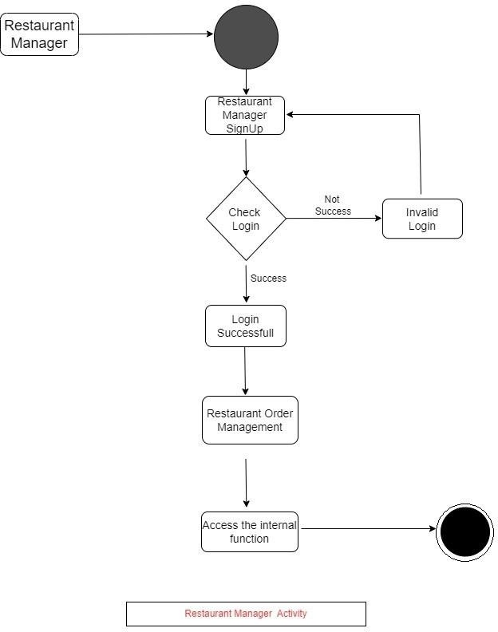

*Restaurant Manager Activity:



6

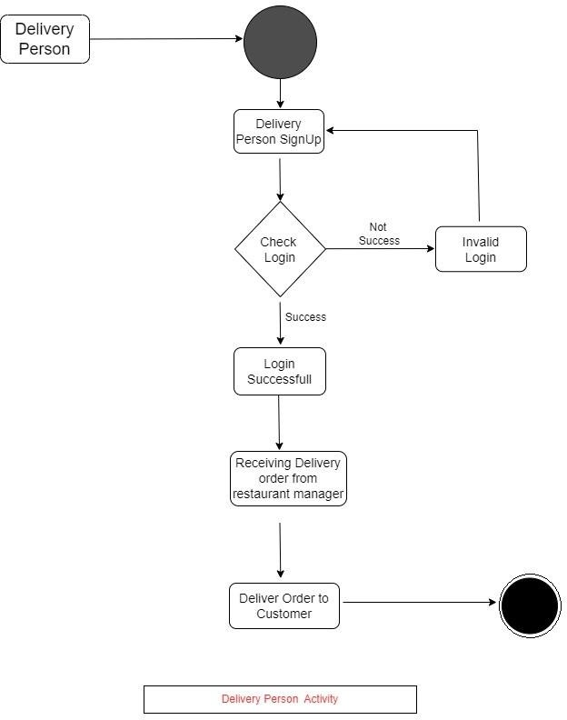

*Delivery Person Activity:



7

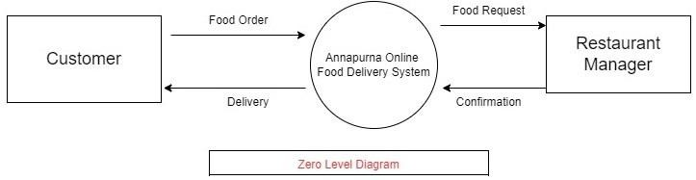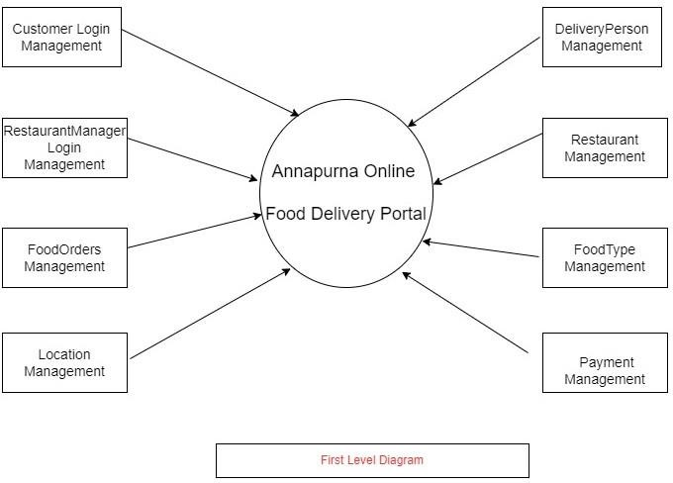

## Data Flow diagram:



8

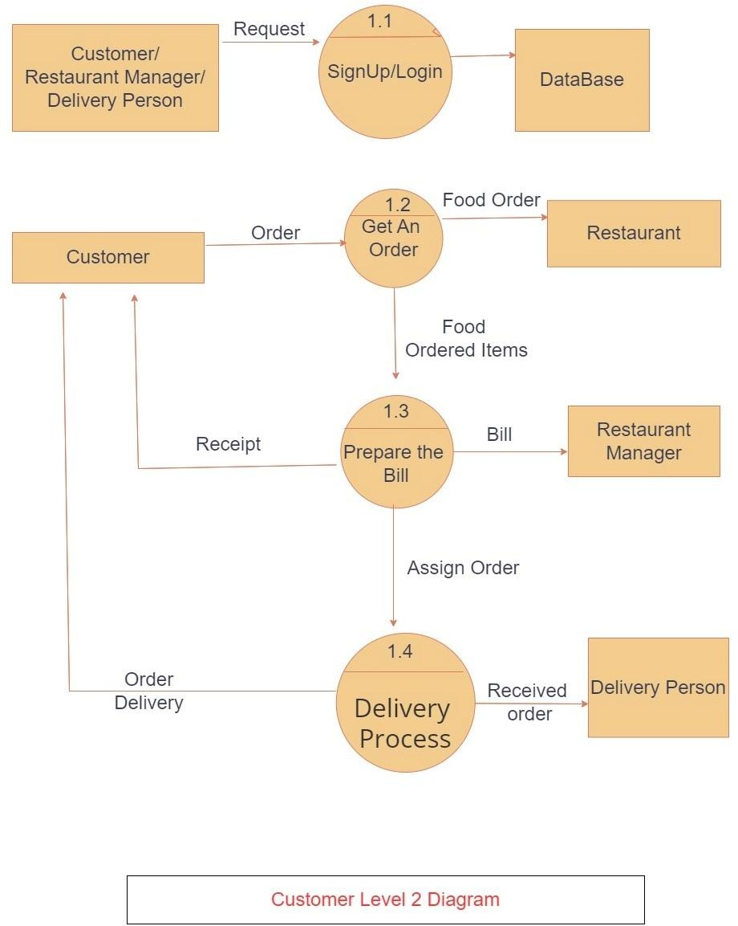

9

## Class Diagram:

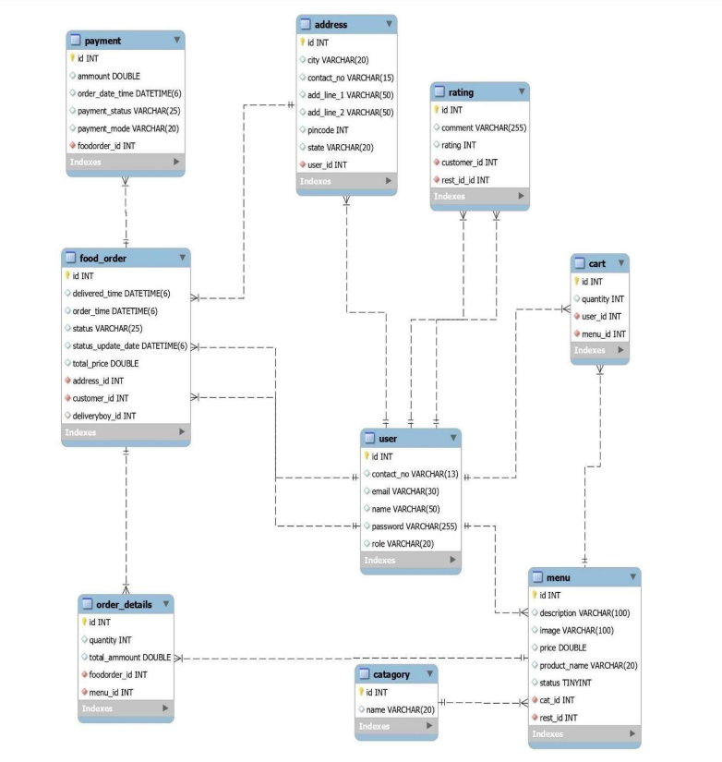

10

## Use Case Diagram:



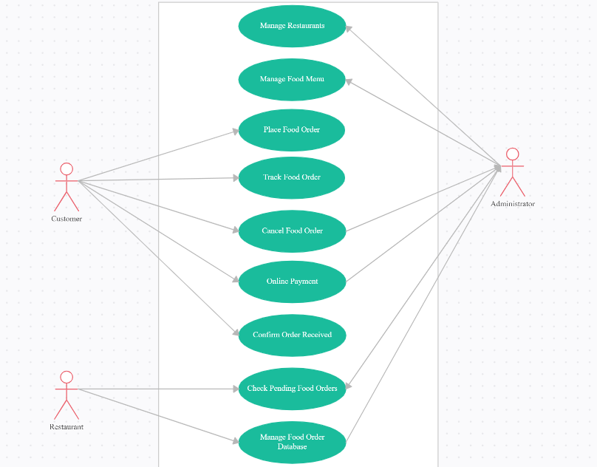



11

## ER Diagram:

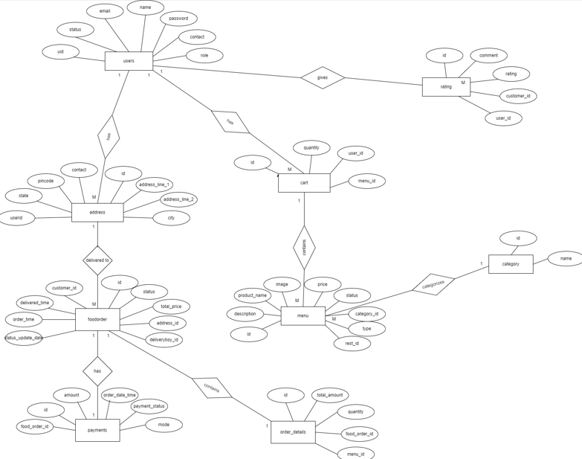

12

# TABLE STRUCTURE.

* user:

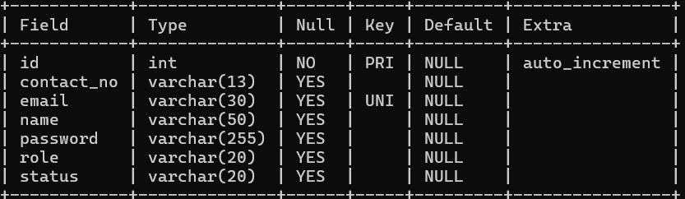

* address:

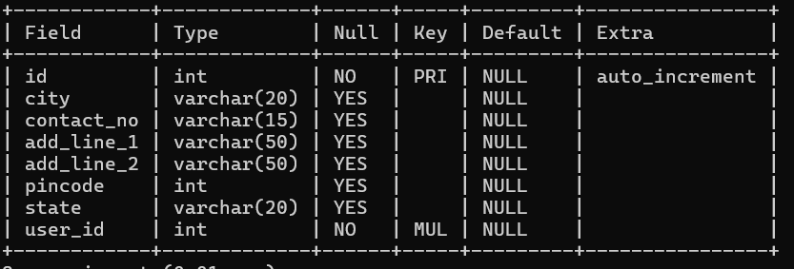

* cart:
* 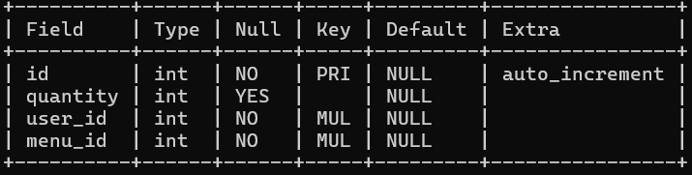

13

* category:
* 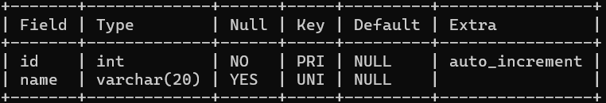
* Food_order:
* 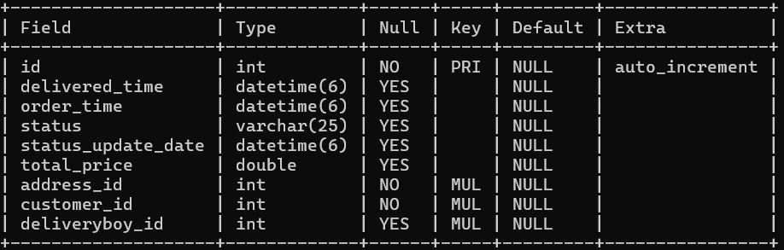

14

* menu:
* 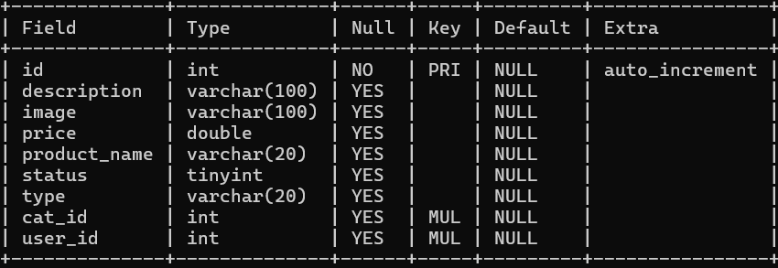

Payment:

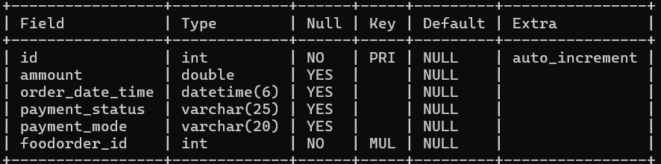

15

* Order_details:
* 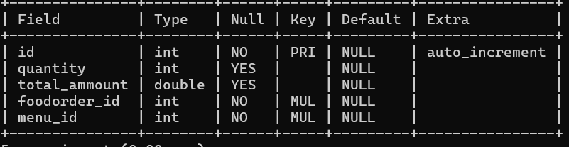
* Rating :

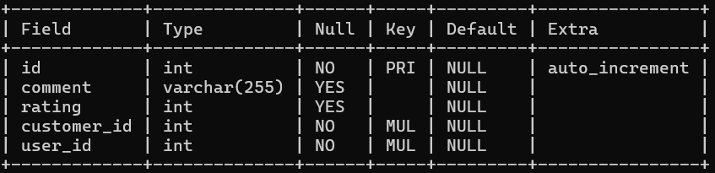

16

# CONCLUSION

## Conclusion:

Online food delivery system is process of ordering food through single web portal with access to multiple restaurants at the same time. It provide customers an access to various food items from various hotels and helps to try new foods.It provide restaurant manager to increase the business of their hotel.it also provide home delivery of foods with help of delivery person**.**

## Future Scope:

This project can be enhanced further by adding payable additional hotels, online feedback system, local mess for the members to increase the variety of the foods. The software is flexible enough to be modified and implemented as per future requirements. We have tried our Best to present this free and user–friendly website to customers.

17

**9.Screenshots :**

Home Page

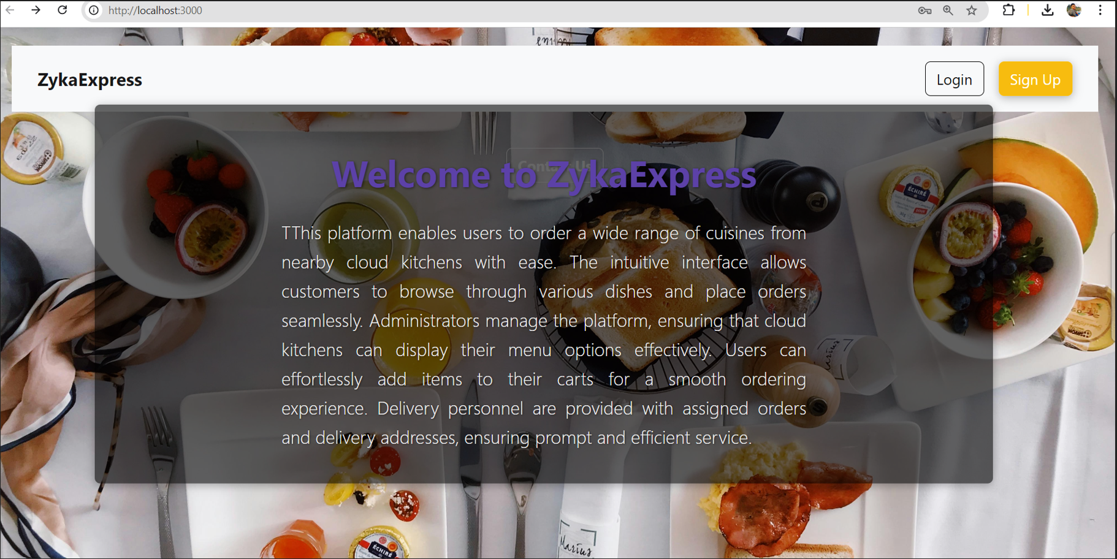

Sign In

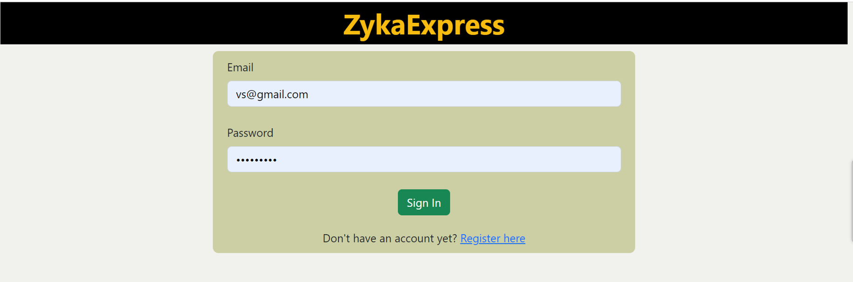

SignUp

18

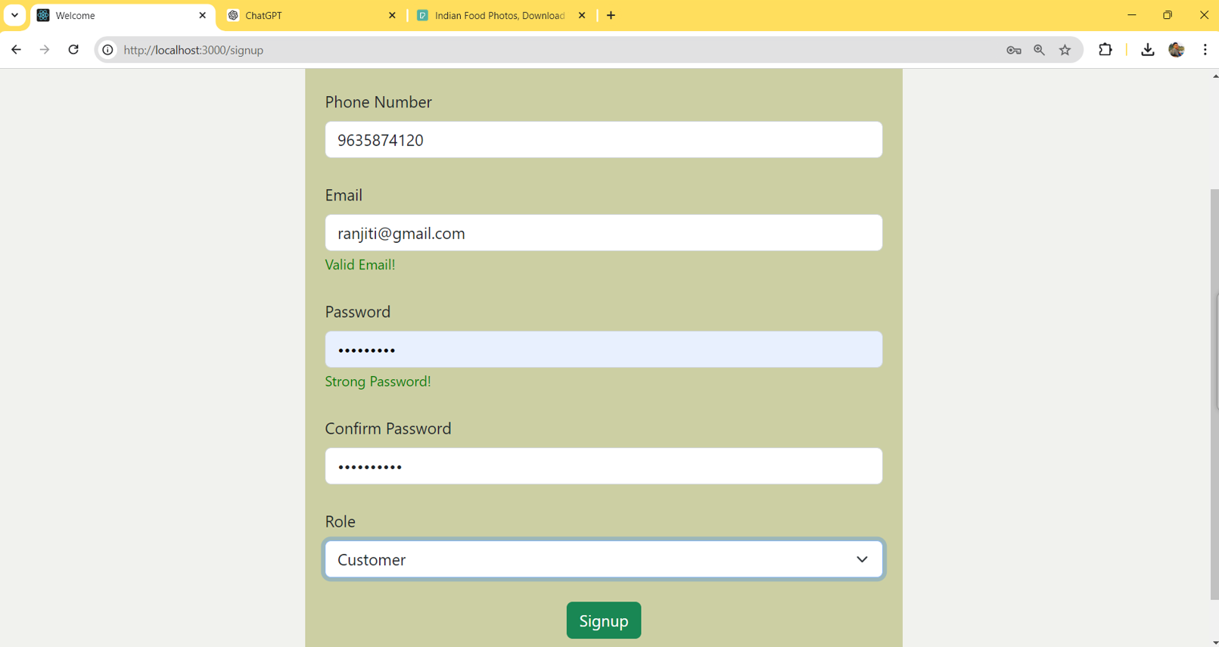

Customer Home

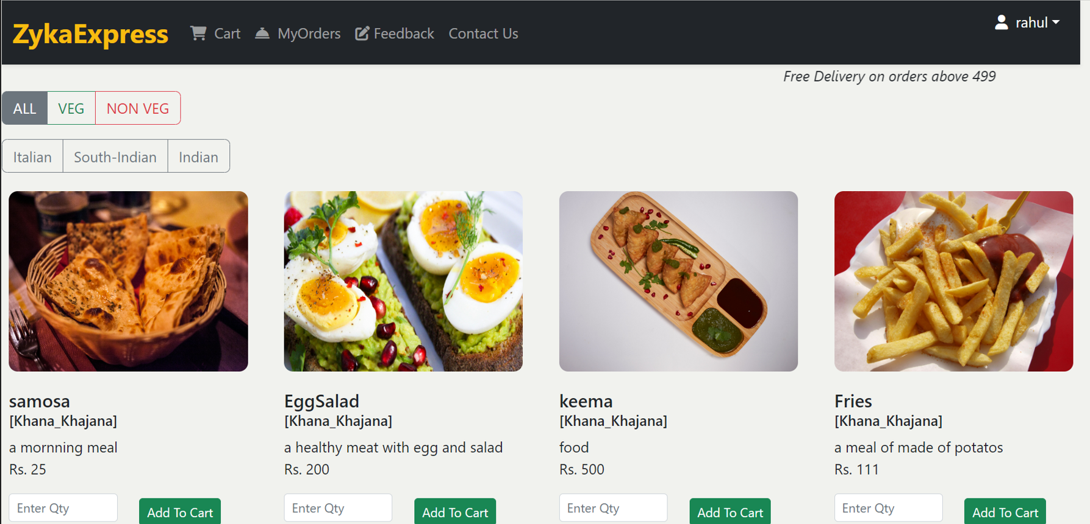

Customer Cart

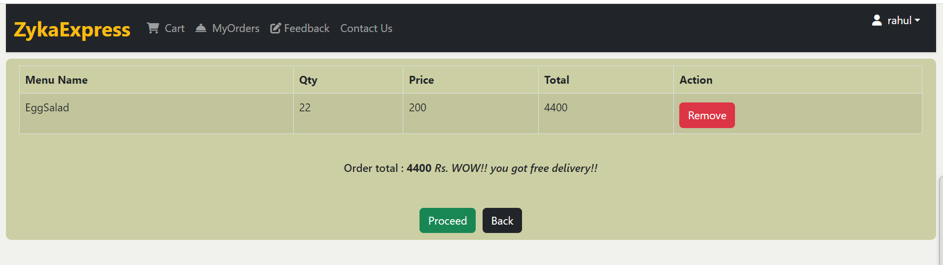

19

Customer Orders

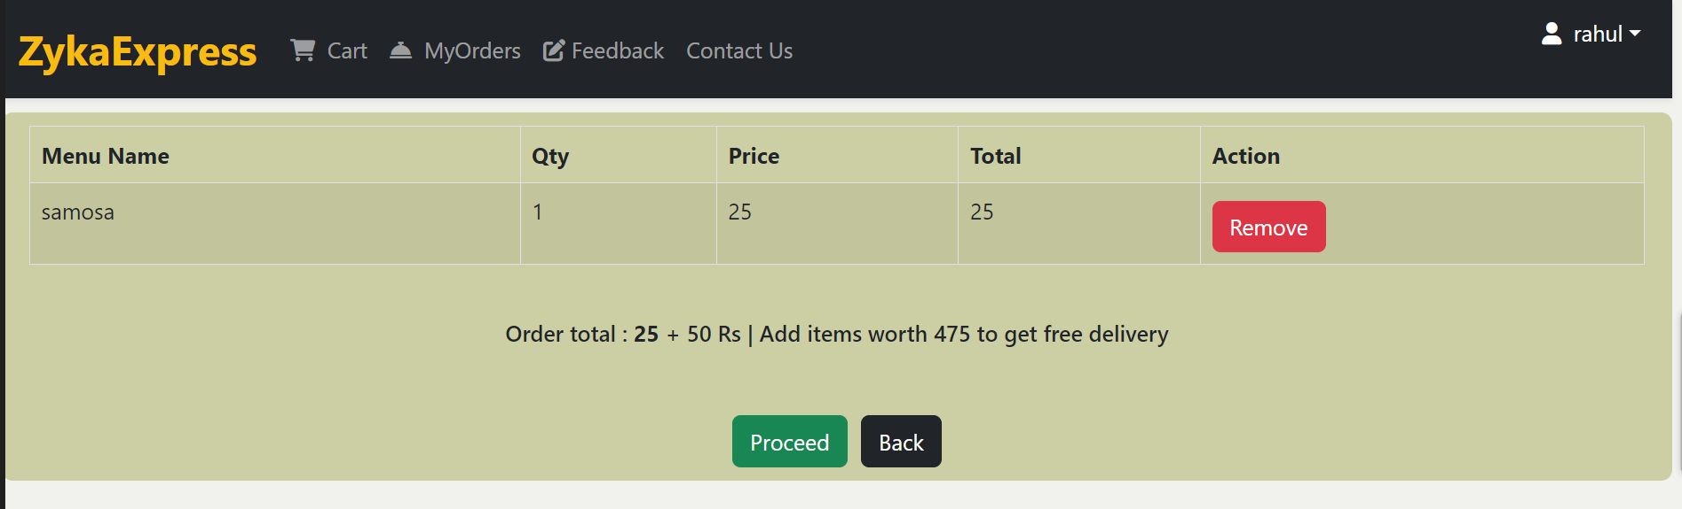

Rating

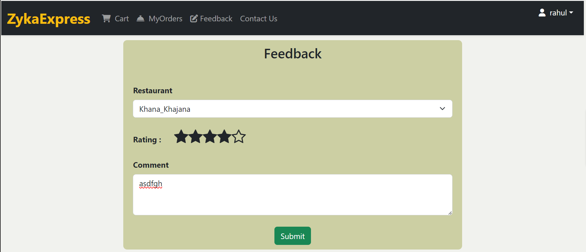

Update Profile

Restaurant Home (New Orders)

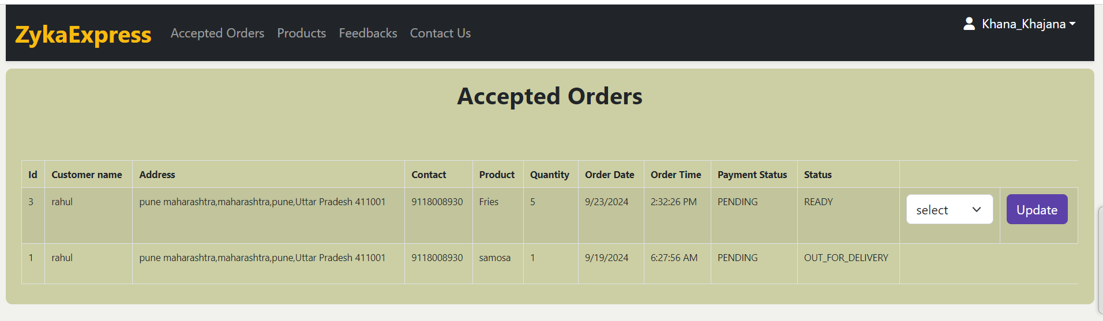

20

Restaurant Accepted Orders

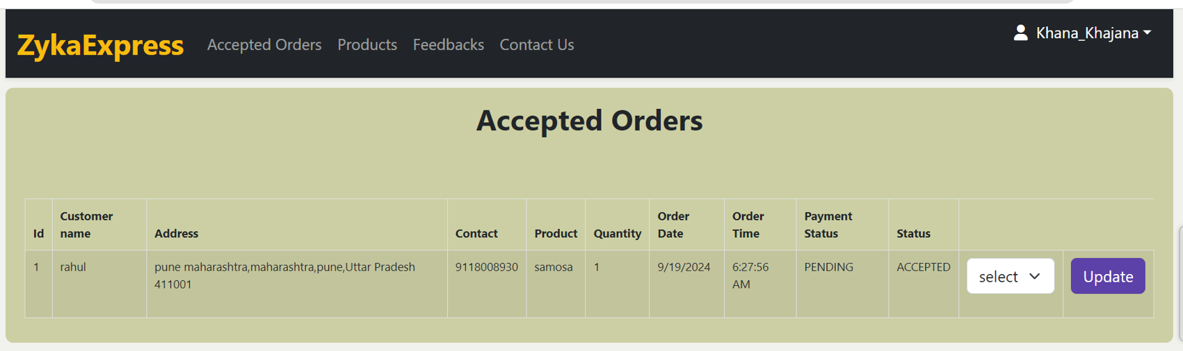

Restaurant Products

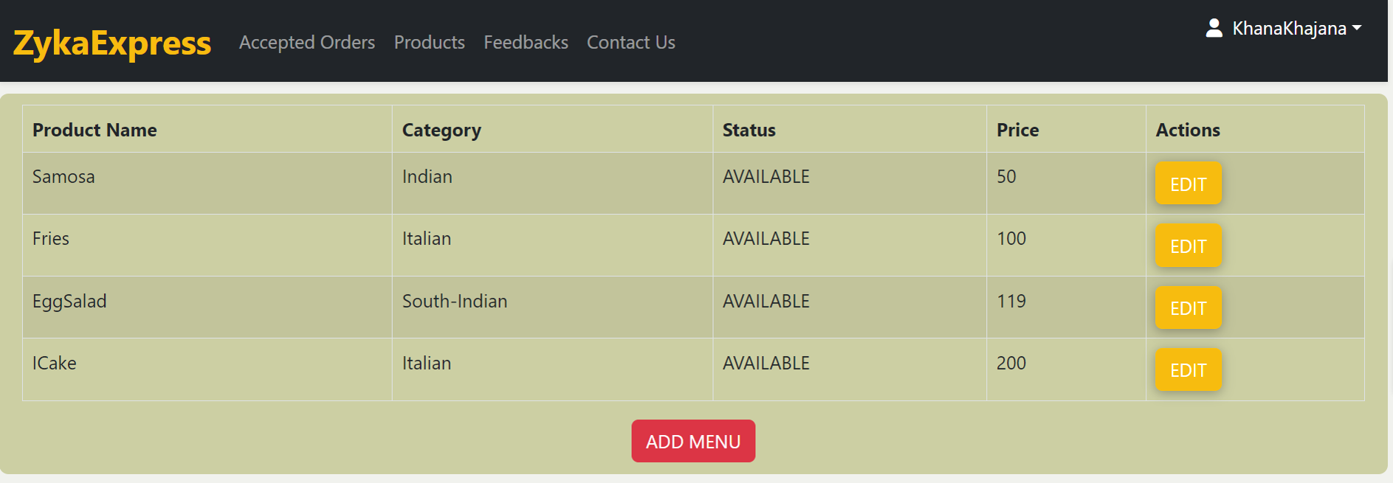

Restaurant Feedbacks

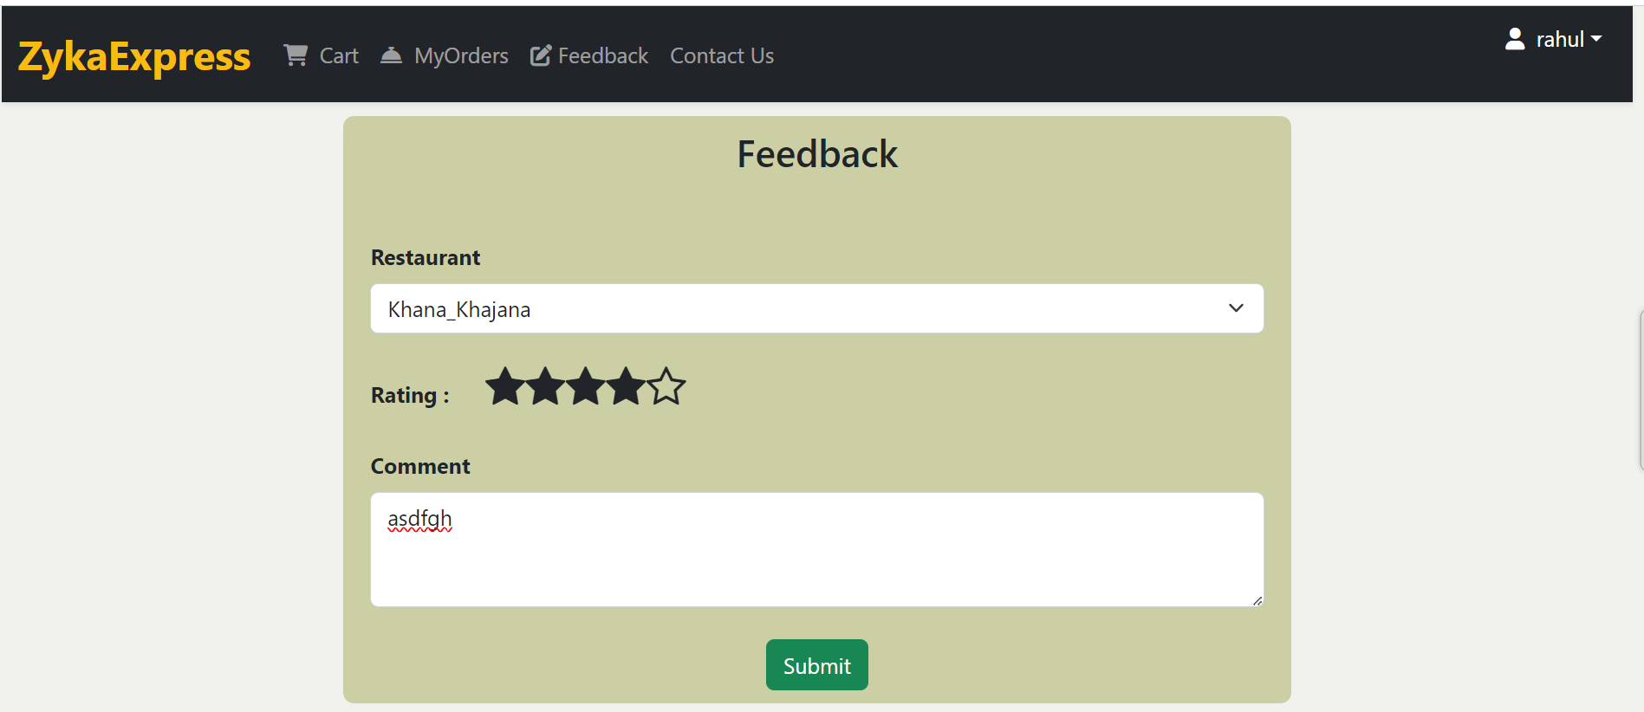

DeliveryBoy Home (New Orders)

21

DeliveryBoy Accepted Orders

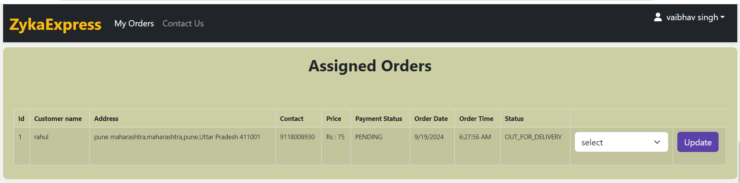

Admin Home

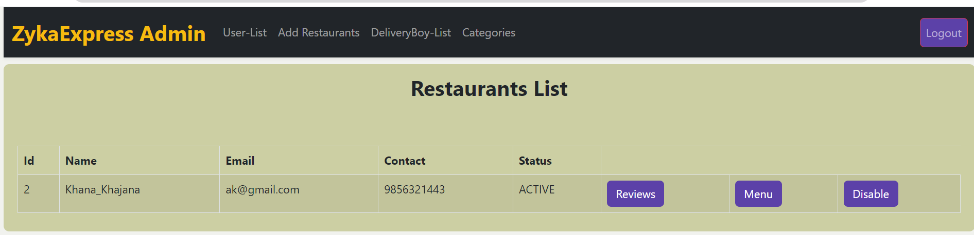

Customers List

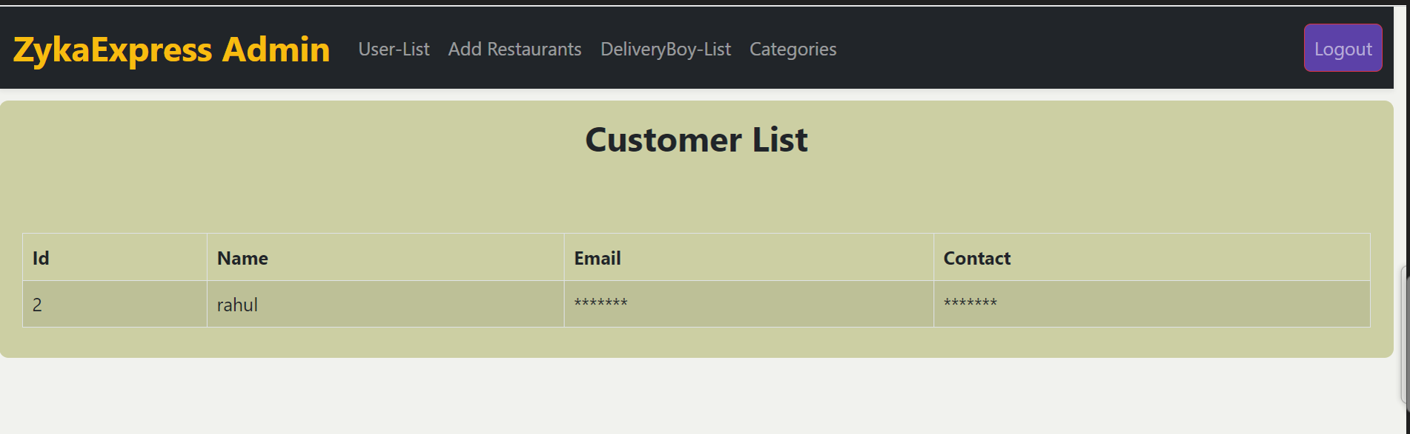

DeliveryBoy List

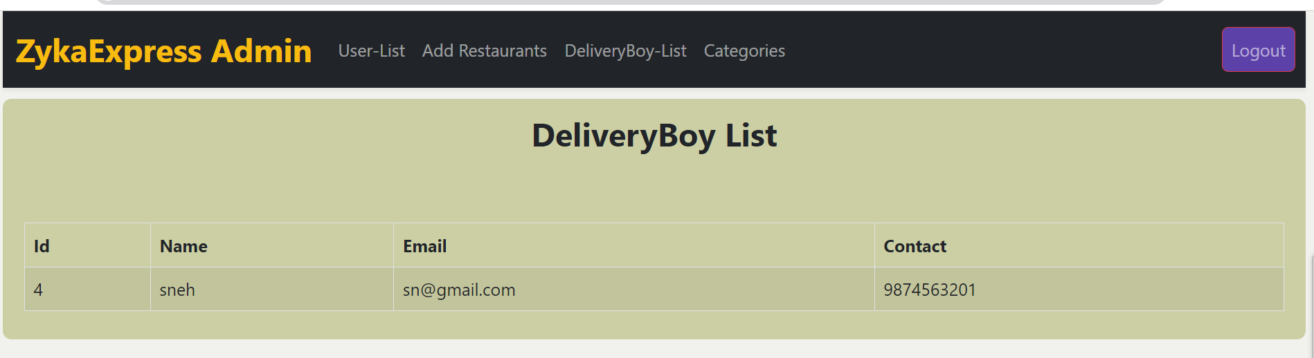

22

Admin Add Restauent

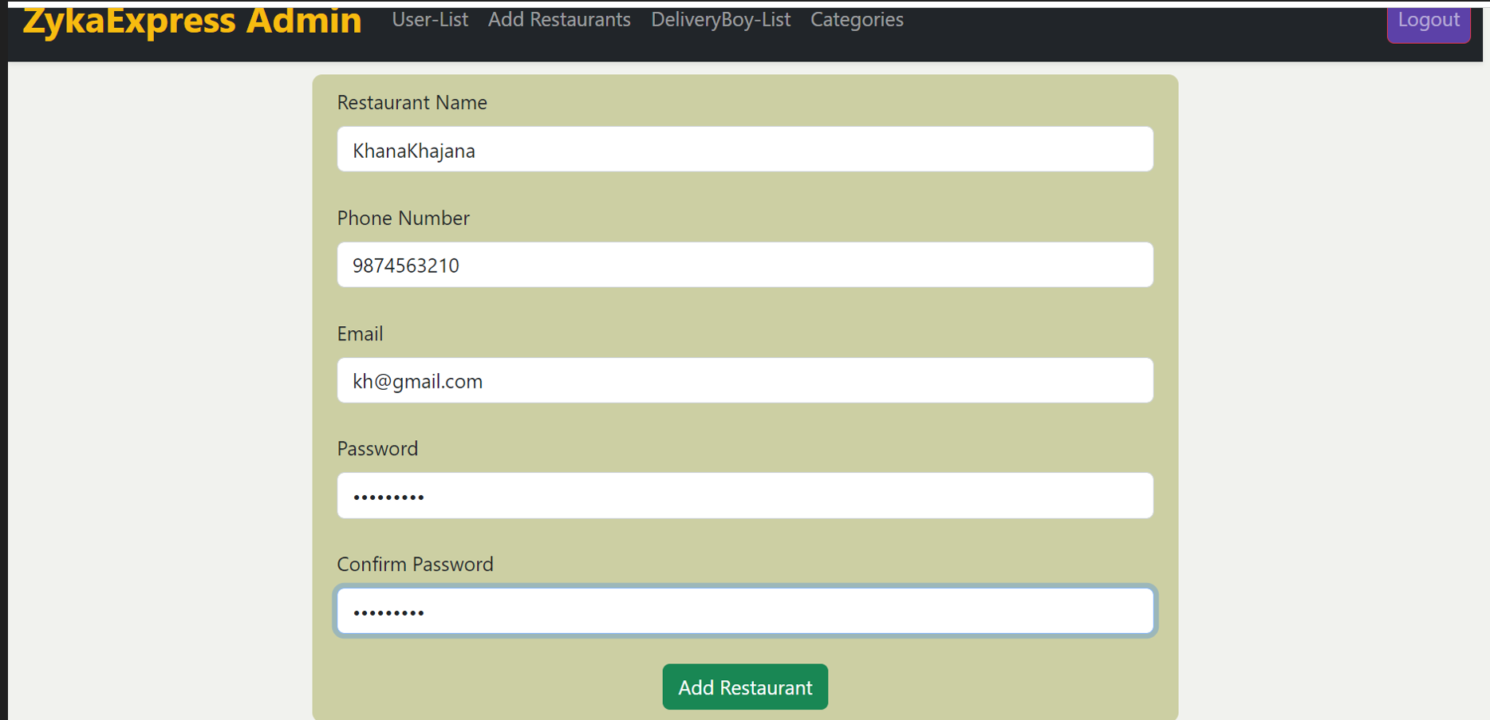

Admin Add Category

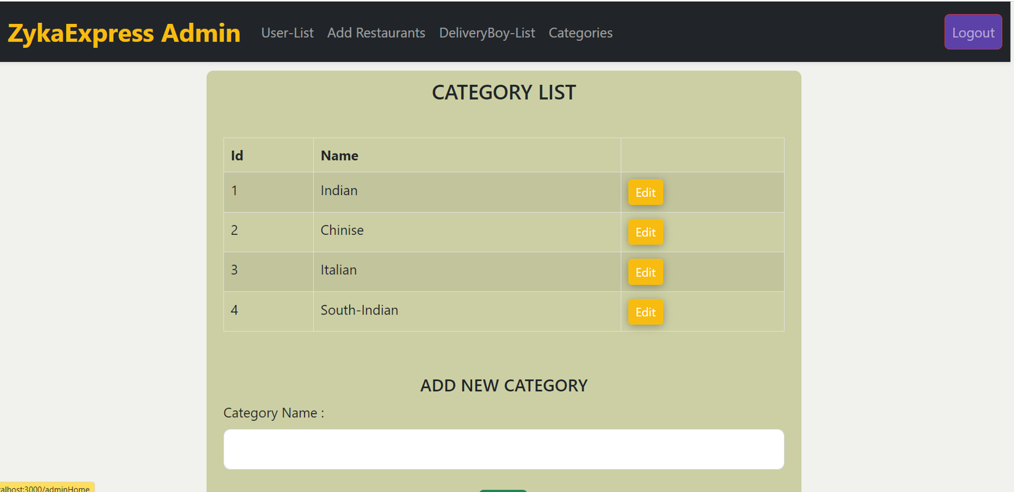

23

* 1. **APPENDIX**

## References:

****<http://www.ijcstjournal.org/volume-7/issue-1/IJCST-V7I1P4.pdf> <https://bootstrapmade.com/mentor-free-education-bootstrap-theme/> <https://www.javatpoint.com/java-mail-api-tutorial> https://[angular.io/docs](https://angular.io/docs)

**<https://javaee.github.io/javaee-spec/javadocs>[/](https://javaee.github.io/javaee-spec/javadocs/) <https://www.w3schools.com/>

24